**DBMS Assignment**

Sanika Kadam

2124UCSF1112

**Topic: Travel Tracker**

**Database Schema Design for Traveltracker**

**It has Primary key**

CREATE DATABASE TravelTracker;

USE TravelTracker;

CREATE TABLE Destinations (

Destination_ID INT PRIMARY KEY,

City VARCHAR(100),

Country VARCHAR(100),

Continent VARCHAR(50),

Travel_Date DATE --

);

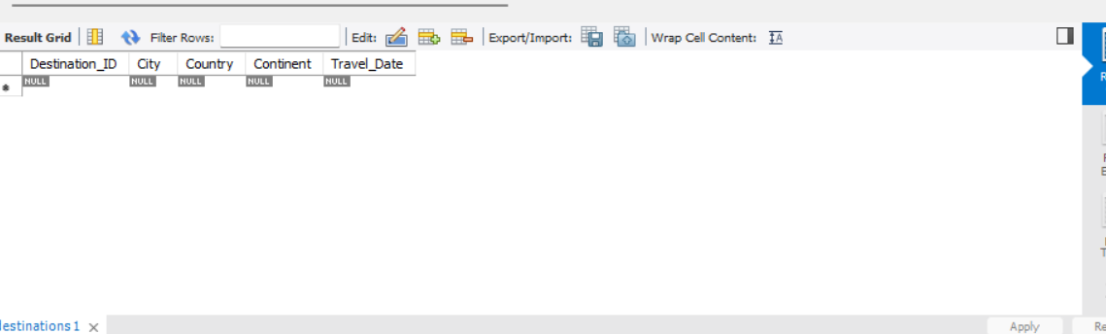

**Data Insertion**

INSERT INTO Destinations (Destination_ID, City, Country, Continent, Travel_Date)

VALUES

(1, 'Tokyo', 'Japan', 'Asia', '2025-06-15'),

(2, 'Paris', 'France', 'Europe', '2025-09-01'),

(3, 'New York', 'USA', 'North America', '2025-12-10'),

(4, 'Sydney', 'Australia', 'Oceania', '2025-08-20'),

(5, 'Cairo', 'Egypt', 'Africa', '2025-11-05'),

(6, 'Rio de Janeiro', 'Brazil', 'South America', '2025-10-15'),

(7, 'Moscow', 'Russia', 'Europe', '2025-07-30'),

(8, 'Mumbai', 'India', 'Asia', '2025-06-25'),

(9, 'Bangkok', 'Thailand', 'Asia', '2025-07-05'),

(10, 'Cape Town', 'South Africa', 'Africa', '2025-08-10');

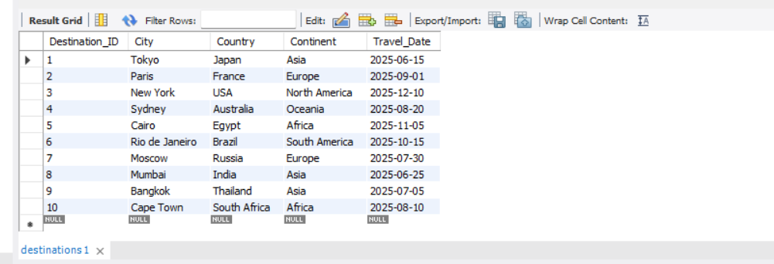

**Create Another Table it has Foreign Key**

CREATE TABLE IF NOT EXISTS Travelers (

Traveler_ID INT PRIMARY KEY,

Name VARCHAR(100),

Age INT,

Destination_ID INT,

Travel_Purpose VARCHAR(100),

FOREIGN KEY (Destination_ID) REFERENCES Destinations(Destination_ID)

);`

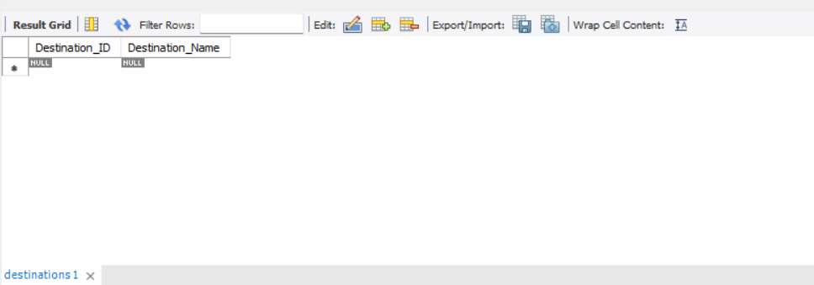

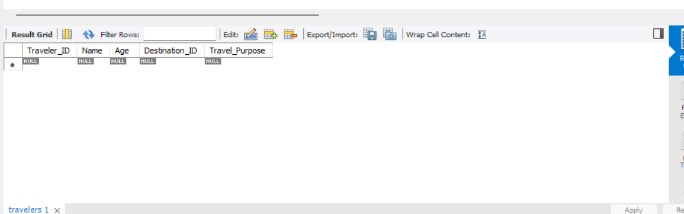

**Data Insertion**

INSERT INTO Travelers (Traveler_ID, Name, Age, Destination_ID, Travel_Purpose)

VALUES

(1, 'Sanika Kadam', 30, 1, 'Vacation'),

(2, 'Venu More', 25, 3, 'Business'),

(3, 'Smith Chavan', 40, 7, 'Vacation'),

(4, 'Shlok Lee', 35, 5, 'Tourism'),

(5, 'Ram Davis', 28, 9, 'Conference'),

(6, 'Sonu Lee', 32, 2, 'Vacation'),

(7, 'Harry Wilson', 45, 4, 'Business'),

(8, 'Ishwari Clark', 29, 6, 'Tourism'),

(9, 'Janavi Harris', 38, 8, 'Conference'),

(10, 'Shifa Moore', 26, 10, 'Vacation');

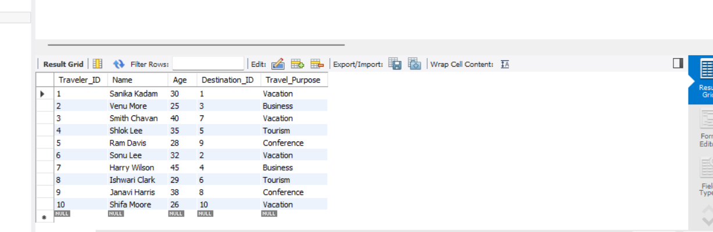

**Now perform A JOIN query that retrieves data from both table**

USE TravelTracker;

SELECT

Travelers.Traveler_ID,

Travelers.Name AS Traveler_Name,

Travelers.Age,

Travelers.Travel_Purpose,

Destinations.City,

Destinations.Country,

Destinations.Continent,

Destinations.Travel_Date

FROM

Travelers

JOIN

Destinations

ON

Travelers.Destination_ID = Destinations.Destination_ID

LIMIT 0, 1000;

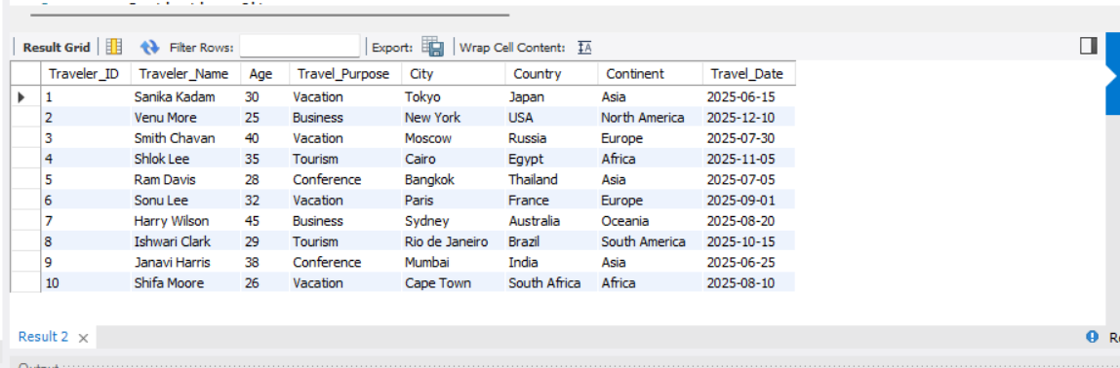

**An aggregate query using functions such as COUNT, SUM, AVG, or GROUP BY.**

**Use COUNT Function**

USE TravelTracker;

SELECT

Destinations.City,

COUNT(Travelers.Traveler_ID) AS Number_of_Travelers

FROM

Travelers

JOIN

Destinations

ON Travelers.Destination_ID = Destinations.Destination_ID

GROUP BY

Destinations.City;

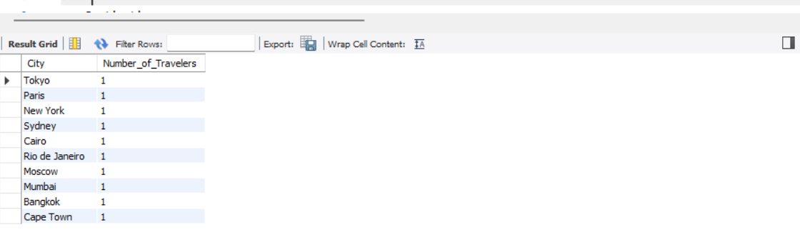

**Conclusion :**

The "Travel Tracker" database schema is efficiently designed to organize and analyze travel-related information. It includes two interconnected tables: Destinations, containing details about cities, countries, continents, and travel dates; and Travelers, storing traveler information linked through a foreign key. Queries demonstrate seamless data retrieval, such as combining traveler details with destinations or aggregating the number of travelers per city. This schema simplifies management and enhances data insights for travel analysis.By using queries, you can see traveler details with their destinations or count how many travelers visited each city. This setup makes managing and analyzing travel data simple and effective.